The Swamp Wars, PRAY & Inform With Brotherly Love
February 24, 2017

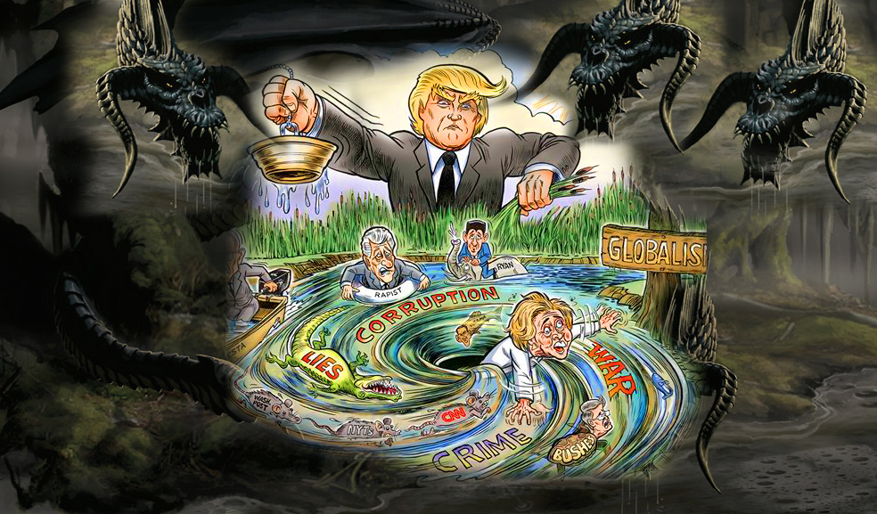
May the wisdom and perseverance of our Lord Jesus strengthen us in this hour.

Dear Heartdwellers - as I work with music, I am struggling with what to do when. Please forgive me for not being as consistent as I should with the messages. The Lord corrected me today. Pray for me that I can do both with ease. For truly the Lord’s grace is there. I just get very confused about what to do next! Please forgive me for disappointing you.

Well, the last thing that came to mind and got derailed out of a message, because of my confusion and laziness, (for the Lord said I was lazy and He knows the truth, no matter how I might try to gloss it over) was Draining the Swamp.

I felt constrained to talk about draining the swamp. Our government has been corrupt on so many levels for so long and in that swamp are all kinds of filth, from disease-carrying mosquitoes to Leviathans. And now the water has been removed and wickedness which was hidden from view is now visible and fighting furiously to keep from being caged.

Lord, I would prefer You talk about this. What would You like to say?

Jesus began, "It is shocking to the American people what has been going on right under their noses. In fact, it is so shocking that no one wants to believe it. And this is being exploited by the elite-controlled media. The more water drained from the swamp, the more vicious the retaliation. This is where My Christian people can have the victory. Defend the truth, expose lies, and stand in solidarity behind this man - President Trump.

"Many rumors and false reports are being generated about him in order to destabilize the government, but My praying Christian people are nipping these lies in the bud with prayer. Prayer, prayer and again I say: prayer. Yes, you have all suffered greatly for this man and for what is right, and your prayers are keeping the attackers at bay. But he needs prayers for strength: morally, spiritually, physically and emotionally.

"The underground government is coming out from hiding and using many uninformed people with no interest in doing what is right for this nation."

Lord, how can this be stopped?

"I am working on the hearts of many. But being informed and informing those who have no understanding will turn the tide one by one. Exposing the truth is your greatest weapon next to prayer. There is a desperate battle going on in their attempt to overthrow the government. That is why so many of you are being called to the front lines in prayer and offerings and every kind of suffering under the sun. We are going to WIN this battle, but it is ferocious.

"In the meantime, I am calling upon you, Heartdwellers, to launch your gifts, as well as fight against injustice and corruption. Just as Nehemiah fought as he rebuilt the wall, so you, too, must keep your sword in one hand while you create and minister with the other".

Oh, Jesus, I feel so impotent in this battle.

"Not so, Clare. You have plenty to offer and your communions are powerful. Don’t give up, Beloved. Both of you have done your part in intercession. You cannot see the impact of all who are praying, but you are an integral part of that, because you exhort others.

"Wake up America, wake up! Time to see the reality of your political system for what it has been and still is. Time to hold your representatives accountable for their allegiances and the way they are attacking those 'draining the swamp.'

"It is a nasty, dirty business, but My angels are fighting and working hard to turn the tide. Much wisdom and influence of the supernatural kind is being exerted against the enemy. When men love righteousness more than their own lives, this evil will be kept at bay and even perhaps overthrown. All is in your hands, My People - your prayers, your fasts and offerings. Your ability to inform the uninformed. The little that you do magnified thousands of times, is turning the tide. Keep up the good work."

You know, I had a thought here, guys... I had a thought of, you know how sometimes, airplanes will fly overhead and they'll drop a bunch of leaflets. And I just had a thought about...goodness. You know, these demonstrators don't know what they are fighting for! They had no idea what they're doing. And that they're cutting their noses off to spite their face!

A lot of them are the poor and those who need some form of income. And if they knew that they were cutting their noses off to spite their face, I don't think they'd take it. I think they'd look for a job instead. Maybe I'm naive, but I think that if we had little flyers, or little folders - I'm not talking about me, because the Lord isn't calling me to get involved in that. But, some of you who would feel the burden to do so, to have little folders that would explain what we're fighting against, that you could pass out to demonstrators - it might turn them around. It might get them to look in a different direction.

And also for your families. Just a simple letter explaining why the fight is so vicious right now. And what is being exposed. And what the government has been, that they haven't seen. Something to counter-act the lies about President Trump, but something more important - to expose the corruption of the government before him. And even now - the government now. And to expose the media.

If people knew and understood, really understood, the Truth - they would fight against it. So, what I'm suggesting here is, that if any of you feel so inclined, not to write some kind of an ugly paper. But something very informative and concise. With no condemnation in it - just the simple facts. That will turn people's heads more than anything else. You don't want to get involved in promotions. You don't want to provoke people to anger. But you can at least inform them.

The facts: did you know #1. Did you know #2. Did you know #3? Just giving them an idea of what they were fighting! Because many of them don't have a clue. More and more are getting informed, but there's still so many in families that are prejudiced against this man and what he's doing. And they don't even know why. They've just joined the bandwagon and gone with the popular front.

I don't know what method the Lord wants you each to use, but He's asking for us to inform those who don't know any better. Who don't understand the forces that are behind the opposition to Trump. But 'draining the swamp' is definitely a very good analogy for what he's doing right now. And these monsters that have been hiding in that murk HATE him for it. They're coming out in tremendously vicious retaliation to stop him, to discredit him. And to cause Civil War in our country. I think they'd like nothing better than that.

That doesn't have to happen - especially if we handle those who don't understand with kid gloves. Just bring them the facts.

So, the Lord continued here. He said, "I know it has been hard on many of you; very, very hard. (Boy, I can attest to that...) But there has been no other way to garner the strength and force to release graces upon the people. It is a bloody and hard battle and many heroes of the faith have come to the forefront and taken severe losses. Yet their hearts are enlarged during their dwelling prayer with Me and they are doing valiantly.

"So, please, do not be discouraged by the raging storm, the personal struggles and attacks in this hour. Rather, rise up to bear witness to the truth and gently, in charity and brotherly accord, reach out to the uninformed to reveal the true intentions and source of the opposition and what they stand to lose if they continue on in ignorance.

"I am with you in this battle. Let your prayers and offerings precede anything you do, and consider it your duty to inform the uninformed. Always in brotherly love and never in contentiousness or malice.

"I am with you, precious ones, and every one of your efforts brings Me great comfort that truly, you do care for the children of this world as I do."

